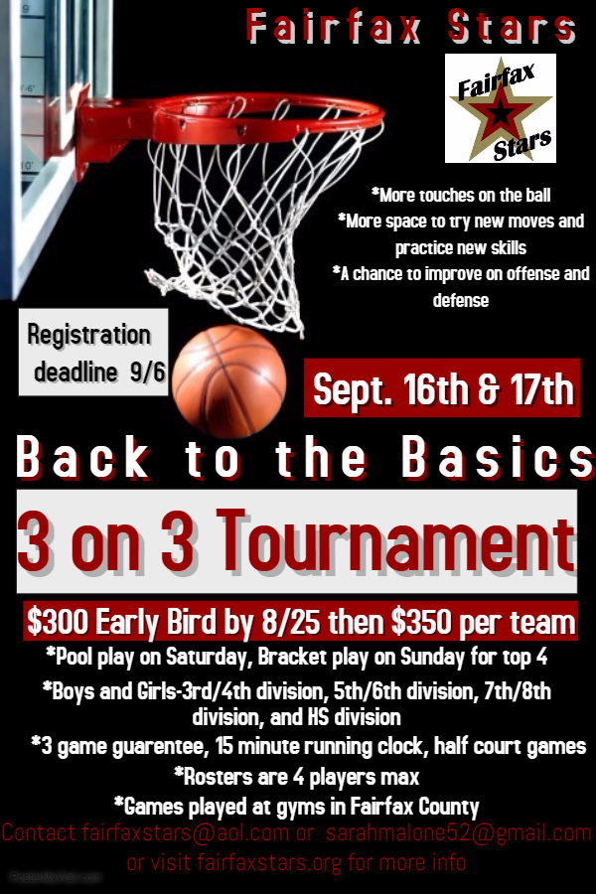

Fairfax Stars “Back to the Basics” 3 on 3 Tournament Registration and Roster Form
FILL OUT COMPLETELY AND LEGIBLY

_____ AAU ____Other

____ Boys ____ Girls _____ Grade as of Fall 2017 _____ Division 1 _____Division 2
TEAM NAME ______________________________ 2nd Contact Info - (Asst. Coach or Parent)
Coach Name: _________________________________ Name ____________________________
Phone (H) _____________________________________ Phone (H) __________________________
Cell Phone: ___________________________________ Cell Phone: _________________________
Email (H) _____________________________________ Email (H) ___________________________
Email (W) ____________________________________ Email (W) __________________________
Schedule Requests (not guaranteed): _________________________________________________________________________________________________
________________________________________________________________________________________________________________________________
________________________________________________________________________________________________________________________________
Registration fee may be paid online at www.fairfaxstars.org or mailed.
Mail Registration form/roster and payment made out to Fairfax Stars to: Fairfax Stars 2801 Glade Vale Way Vienna, VA 22181
OR email completed form and roster to sarahmalone52@gmail.com and fairfaxstars@aol.com.
League Use Only: Check# ________ Amt Pd _______
Fairfax Stars 3 on 3 Tournament Roster
Please fill out and submit roster with all information filled in.
 | Player Name | Jersey # | DOB | Grade as of Fall 2017 | Address | County of Residence
1
2
3
4

