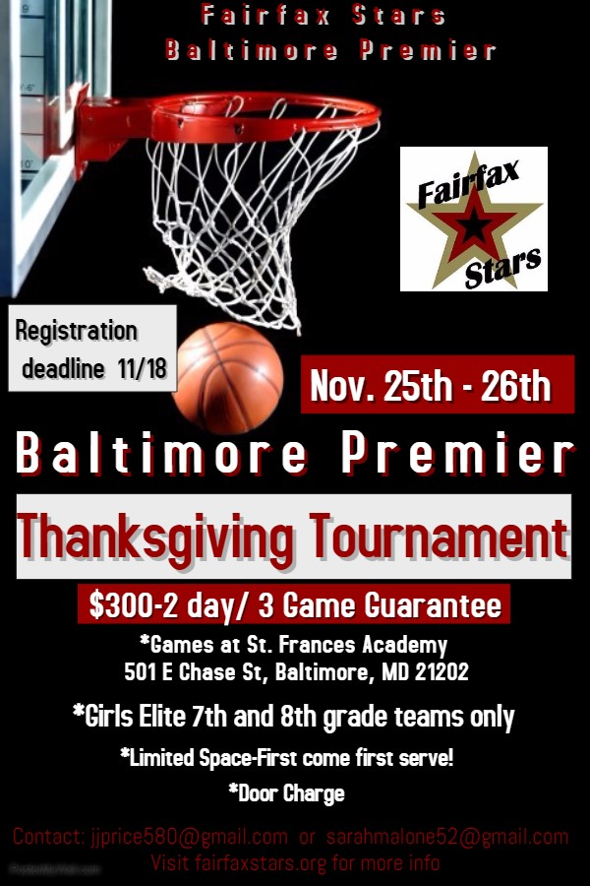

Fairfax Stars Baltimore Premier Thanksgiving Tournament Registration Form
FILL OUT COMPLETELY AND LEGIBLY

_____ AAU ____Other
_____ Grade as of Fall 2017 _____ Division 1 _____Division 2

TEAM NAME ______________________________ 2nd Contact Info - (Asst. Coach or Parent)
Coach Name: _________________________________ Name ____________________________
Phone (H) _____________________________________ Phone (H) __________________________
Cell Phone: ___________________________________ Cell Phone: _________________________
Email (H) _____________________________________ Email (H) ___________________________
Email (W) ____________________________________ Email (W) __________________________

Schedule Requests (not guaranteed): __________________________________________________________________________________________________
__________________________________________________________________________________________________
__________________________________________________________________________________________________
__________________________________________________________________________________________________
__________________________________________________________________________________________________

Registration fee may be paid online at www.fairfaxstars.org or mailed.
Mail Registration form and payment made out to Fairfax Stars to: Fairfax Stars 2801 Glade Vale Way Vienna, VA 22181
OR email completed form to sarahmalone52@gmail.com and fairfaxstars@aol.com.

League Use Only: Check# ________ Amt Pd _______

