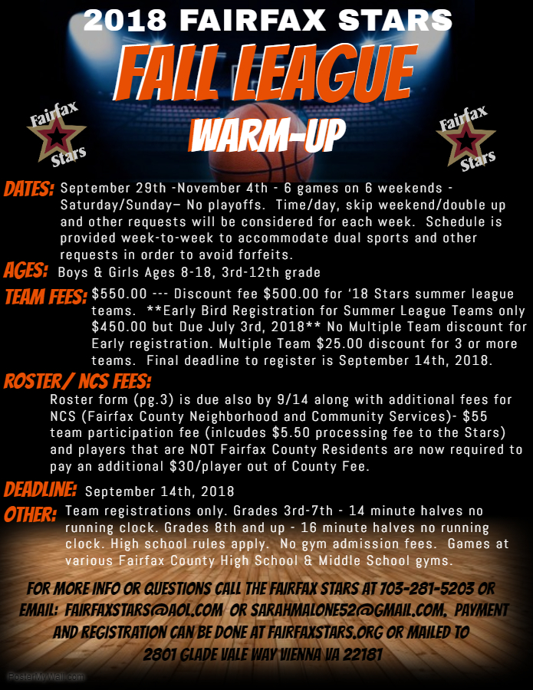

2018 Fairfax Stars Fall League Registration Form
TEAM REGISTRATIONS ONLY. You can also register and pay at: www.fairfaxstars.org

PLEASE FILL OUT COMPLETELY AND LEGIBLY

_____ County _____CYO BOYS _____ GIRLS _____ Div 1 _____ Div 2 _____
____ AAU _____ House
____ High School Freshman
____ High School JV Grade Fall 2018: _________
____ High School Varsity

TEAM NAME ______________________________

Coach Name: ______________________________ 2nd Contact Info -- (Asst Coach or Parent) Name: ______________________________
Address/City/St ____________________________ Phone (H) ___________________________

Phone (H) __________________________________ Phone (W) ___________________________

Phone (W) __________________________________ Cell: _______________________________

Cell: ______________________________________ Email (H) ____________________________
Email (H): _________________________________ Email (W) ____________________________

Email (W) _________________________________
---------------------------------------------------------------------------------------------------------------------------------------------------
Registration and NCS Fees payable to Fairfax Stars
MAIL TO: Fairfax Stars, 2801 Glade Vale Way Vienna, Virginia 22181

ONLINE PAYMENT & REGISTRATION ALSO AVAILABLE by visiting www.fairfaxstars.org. Please also fill out and submit the roster form on pg. 3

League Use Only Check # __________________ Amt Paid ________________

2018 Fairfax Stars Fall League Roster
Team Name: _______________________ Gender:_____ Grade:__________ Div._______
 | Player Name | Jersey # | DOB | Grade as of Fall 2018 | Address | County of Residence
1
2
3
4
5
6
7
8
9
10
11
12
13
14
15
16
17
18
Please fill out and submit this page with all information filled in or it will be returned to you.

