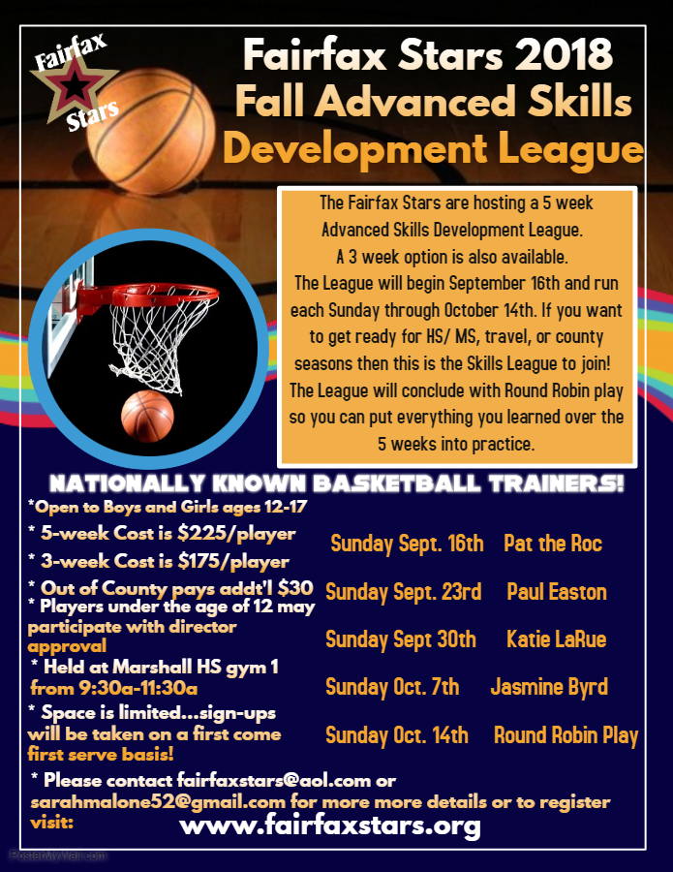

Registration Form for 2018 Fall Advanced Skills Development League
Please type or print CLEARLY

Player Name: ____________________ Gender:_____ Age: ________ Date of Birth: ________

Grade: _____ School Player attends: ____________________________ ________________

Address: _______________________________________________________________________

County of Residence: ______________________________

Phone Number: ___________________ Email Address: ____________________________

Please check which option best describes your skill level/basketball experience…

____ AAU National Team ____ AAU Regional Team ____ Travel Team

Check Number of Sessions signing up for ______ 5 ______ 3(the 3-week option will allow you to choose to attend 2 of the first 4 weeks and you MUST attend the last week for Round Robin play-no exceptions.)

If signing up for 3 sessions, check which 2 you will attend in addition to the final week:

_____ Sunday Sept. 16th Pat the Roc
_____ Sunday Sept. 23rd Paul Easton
_____ Sunday Sept. 30th Katie LaRue
_____ Sunday Oct. 7th Jasmine Byrd
_____ Sunday Oct. 14th Round Robin Play
If any sessions are canceled due to the weather or other unforeseen circumstances, all attempts will be made to make up the session. In the event a session cannot be made up, no refunds will be given.

Forms can be filled out and emailed to fairfaxstars@aol.com or mailed with payment to Fairfax Stars 2801 Glade Vale Way, Vienna, VA 22181
Checks made payable to Fairfax Stars
Registration and Payments can also be completed online at: www.fairfaxstars.org
_______________________________________________________________________________________

For administrative use ONLY

Amount Paid: __________ Payment Method: __________

Complete if paid by check-- Check Number: ______ __ Name on Check: _____________________

