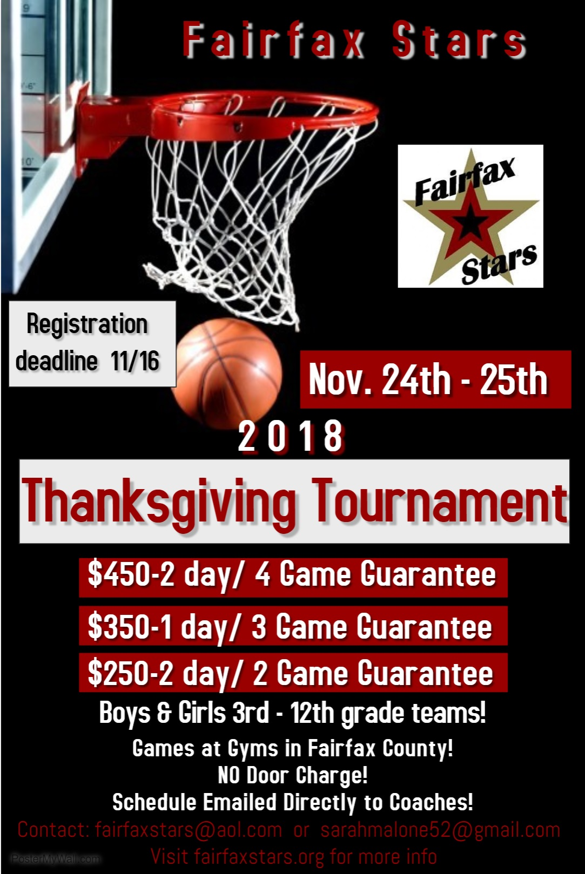

Fairfax Stars Thanksgiving Tournament

Girls & Boys Tournament Registration Form

**Team Name: ______________________ Grade as of Fall 2018: ______**

**Gender: _________**

**Div. I or II: _______ Elite 16/17 (Y or N): ________**

**Coach/Team Contact Name: ____________________**

**Cell phone: _______________**

**Coach/Contact email: _______________________________________________**

**(*Please*, print legibly for all correspondence and schedules)**

**Special schedule requests, please note which day you would like to play if choosing a 1-day option (requests cannot be promised):**

**___________________________________________________________________**

**___________________________________________________________________**

**___________________________________________________________________**

**Please check: $450/ 4 games/ 2 days ________**

**$350/ 3 games/ 1 day _________ (please note Sat. or Sun.)**

**$250/ 2 games/ 1 day _________ (please note Sat. or Sun.)**

**Registration and payments can be mailed to**

**2801 Glade Vale Way Vienna, VA 22181 or done online at fairfaxstars.org.**

**For additional information contact Fairfaxstars@aol.com**

----------------------------------------------------------------------------------------------------------------------------------------------------------------

**For Admin Use ONLY: Payment Amount ________ Check/Order # _____ Name on Check/Order _________**