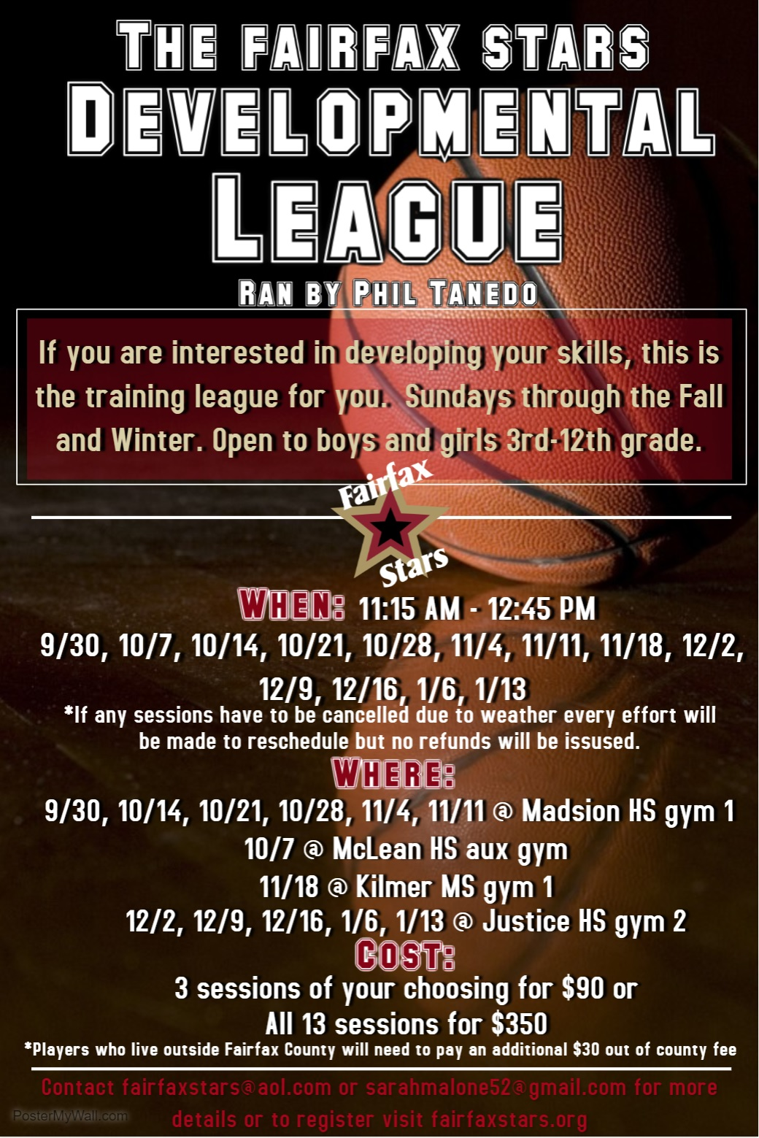

Registration Form for 201-2019 Fairfax Stars Development League
Please type or print CLEARLY

Player Name: ____________________ Gender: _____ Age: ________ Date of Birth: ________

Grade: _____ School Player attends: ____________________ County of Residence: _________________

Address: _______________________________________________________________________

Phone Number: ___________________ Email Address: ____________________________

Please check which option best describes your skill level/basketball experience…

_______ County ______ House ________ AAU _______ other (__________) __________None

Circle Number of Sessions signing up for:

3 - $90 ____13- $350 (*players who live outside Fairfax County will need to pay additional $30 Out of county fee)

If signing up for 3 sessions, check which you will attend:

_____ Sunday Sept. 30th
_____ Sunday Oct. 7th
_____ Sunday Oct. 14th
_____ Sunday Oct. 21st
_____ Sunday Oct. 28th
_____ Sunday Nov. 4th
_____ Sunday Nov. 11th
_____ Sunday Nov. 18th
_____ Sunday Dec. 2nd
_____ Sunday Dec.9th
_____ Sunday Dec. 16th
_____ Sunday Jan. 6th
_____ Sunday Jan. 13th
If any sessions are canceled due to the weather or other unforeseen circumstances, all attempts will be made to make up the session. In the event a session cannot be made up, no refunds will be given.
Forms can be filled out and emailed to fairfaxstars@aol.com or mailed with payment to Fairfax Stars 2801 Glade Vale Way, Vienna, VA 22181
Checks made payable to Fairfax Stars
Registration and Payments can also be completed online at: www.fairfaxstars.org
_______________________________________________________________________________________
For administrative use ONLY

Amount Paid: __________ Payment Method: __________

Complete if paid by check-- Check Number: ________ Name on Check: _____________________

