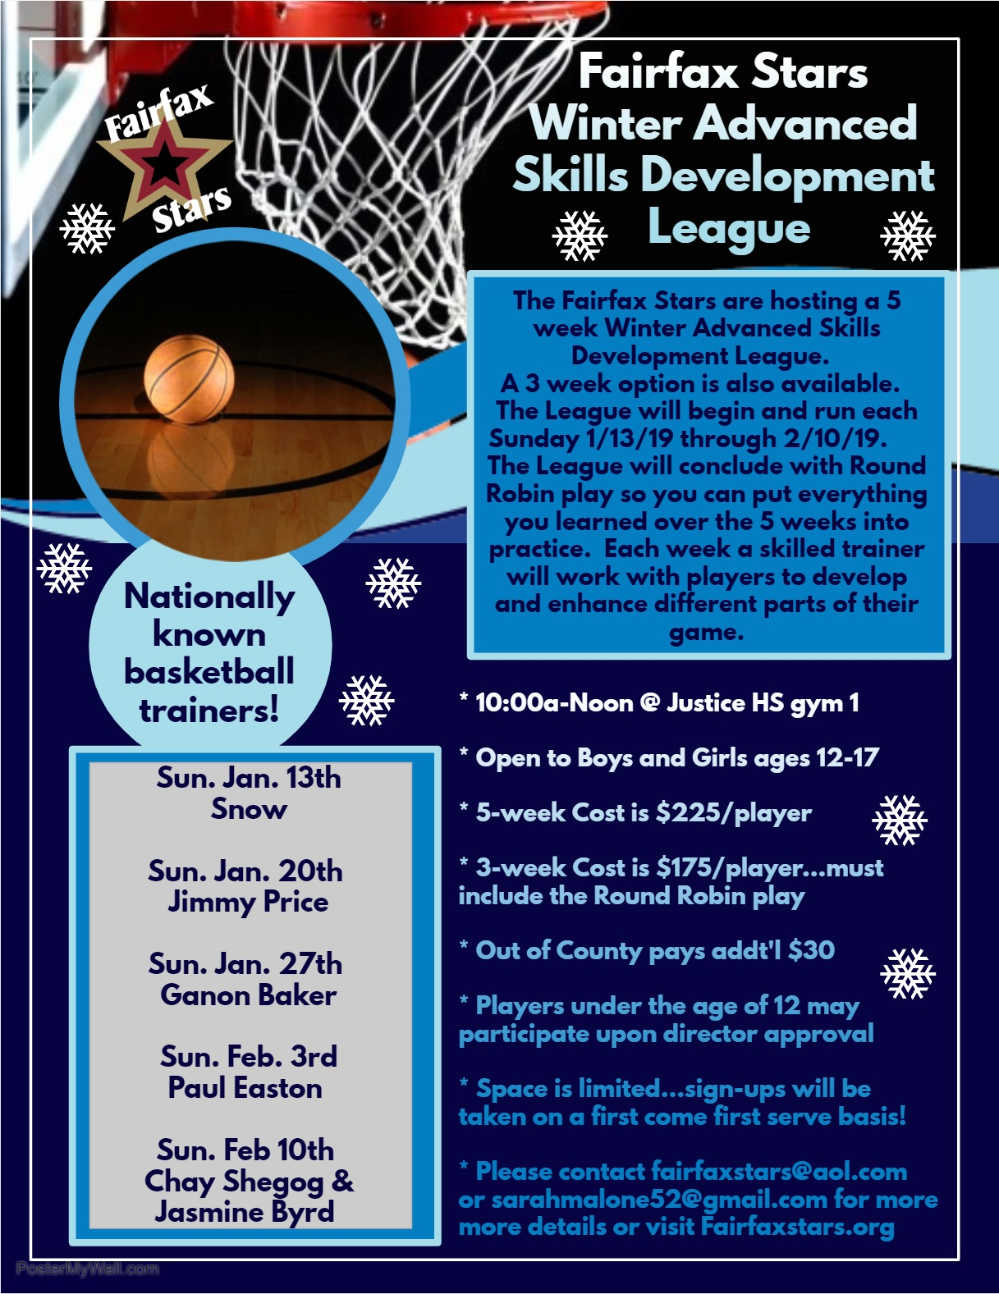

Registration Form for 2019 Winter Advanced Skills Development League
Please type or print CLEARLY

Player Name: ____________________ Gender: _____ Age: ________ Date of Birth: ________

Grade: _____ School Player attends: ____________________________ ________________

Address: _______________________________________________________________________

County of Residence: ______________________________

Phone Number: ___________________ Email Address: ____________________________

Please check which option best describes your skill level/basketball experience…

____ AAU National Team ____ AAU Regional Team ____ Travel Team

Check Number of Sessions signing up for ______ 5 ______ 3(the 3-week option will allow you to choose to attend 2 of the first 4 weeks and you MUST attend the last week for Round Robin play-no exceptions.)

If signing up for 3 sessions, check which 2 you will attend in addition to the final week:

_____ Sunday Jan. 13st Snow
_____ Sunday Jan. 20th Jimmy Price
_____ Sunday Jan. 27th Ganon Baker
_____ Sunday Feb. 3rd Paul Easton
_____ Sunday Feb. 10th Chay Shegog & Jasmine Byrd
If any sessions are canceled due to the weather or other unforeseen circumstances, all attempts will be made to make up the session. In the event a session cannot be made up, no refunds will be given.

Forms can be filled out and emailed to fairfaxstars@aol.com or mailed with payment to Fairfax Stars 2801 Glade Vale Way, Vienna, VA 22181
Checks made payable to Fairfax Stars
Registration and Payments can also be completed online at: www.fairfaxstars.org
_______________________________________________________________________________________

For administrative use ONLY

Amount Paid: __________ Payment Method: __________

Complete if paid by check-- Check Number: ______ __ Name on Check: _____________________

