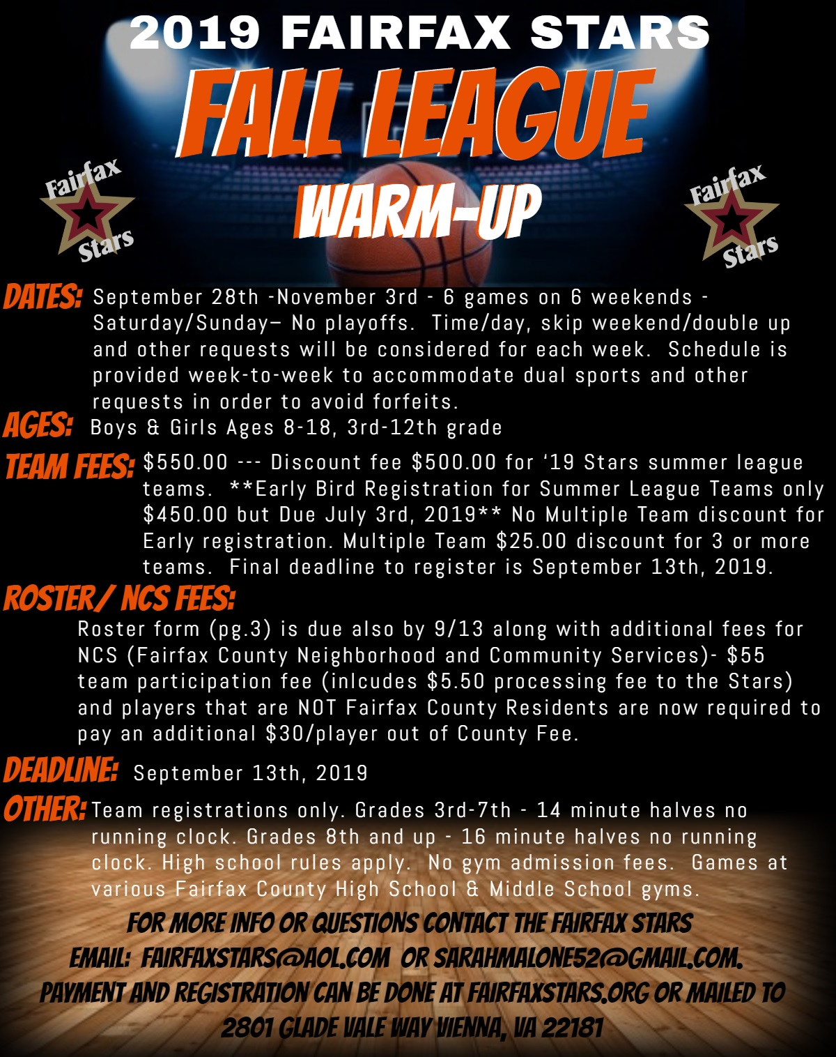

2019 Fairfax Stars Fall League Registration Form
TEAM REGISTRATIONS ONLY. You can also register and pay at: www.fairfaxstars.org

PLEASE FILL OUT COMPLETELY AND LEGIBLY
_____ County _____CYO BOYS _____ GIRLS _____ Div 1 _____ Div 2 _____
____ AAU _____ House
____ High School Freshman
____ High School JV Grade Fall 2019: _________
____ High School Varsity

TEAM NAME: ______________________________ Team Location: ____________________________

Coach Name: ______________________________ Asst. Coach Name: ________________________

Phone (H) _________________________________ Phone (H) _______________________________

Phone (Cell) __________________________________ Phone (Cell) ___________________________

Email (H) __________________________________ Email (H) _______________________________

Email (W)____________________________________ Email (W) ____________________________

Schedule Requests:
________________________________________________________________________________________
________________________________________________________________________________________
________________________________________________________________________________________
________________________________________________________________________________________
Registration and NCS Fees payable to Fairfax Stars
MAIL TO: Fairfax Stars, 2801 Glade Vale Way Vienna, Virginia 22181

ONLINE PAYMENT & REGISTRATION ALSO AVAILABLE by visiting www.fairfaxstars.org. Please also fill out and submit the roster form on pg. 3
---------------------------------------------------------------------------------------------------------------------------------------------------

League Use Only Check #/ Online Payment #____________ Amt Paid ________________

2019 Fairfax Stars Fall League Roster
Team Name: _______________________ Gender:_____ Grade:__________ Div._______
 | Player Name | Jersey # | DOB | Grade as of Fall 2019 | Address | County of Residence
1
2
3
4
5
6
7
8
9
10
11
12
13
14
15
16
17
18
Please fill out and submit this page with all information filled in or it will be returned to you.

