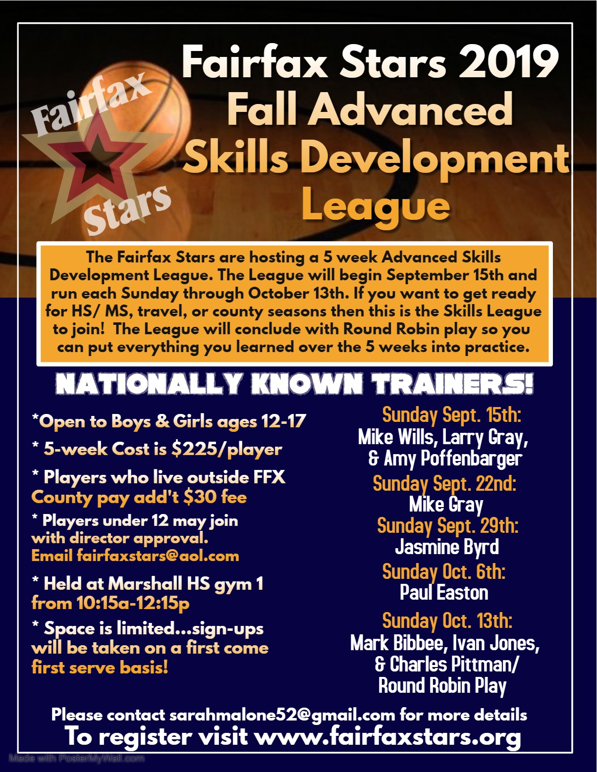

Registration Form for 2019 Fall Advanced Skills Development League
Please type or print CLEARLY

Player Name: ____________________ Gender:_____ Age: ________ Date of Birth: ________

Grade: _______ School Player attends: ________________
__________________________ ________________

Address: _______________________________________________________________________

County of Residence (players who live outside FF county owe add’tl $30 fee): ______________________________

Phone Number: ___________________ Email Address: ____________________________

Please circle which option best describes your skill level/basketball experience…

AAU National Team AAU Regional Team Travel Team Other:________________

If any sessions are canceled due to the weather or other unforeseen circumstances, all attempts will be made to make up the session. In the event a session cannot be made up, no refunds will be given.

Forms can be filled out and emailed to fairfaxstars@aol.com or mailed with payment to Fairfax Stars 2801 Glade Vale Way, Vienna, VA 22181
Checks made payable to Fairfax Stars
Registration and Payments can also be completed online at: www.fairfaxstars.org

_______________________________________________________________________________________

For administrative use ONLY

Amount Paid: __________ Payment Method: __________

Complete if paid by check-- Check Number: ______ __ Name on Check: _____________________

