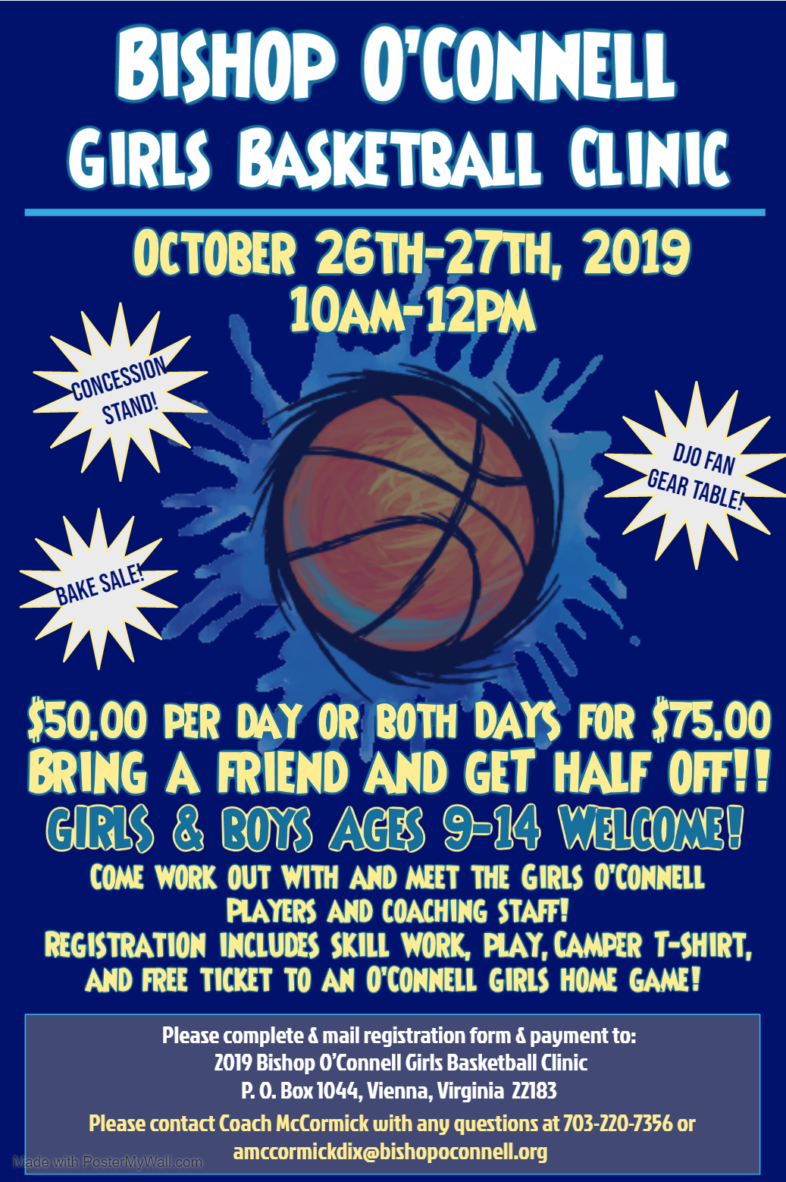
2019 Bishop O’Connell HS Girls Clinic 10/26-27
Player Information:
Player Name: ___________________________________________
School Name: __________________________________ Grade: _______
Birth date: _____/_____/______ Age: _____
Street Address: ___________________________________________________________________________
Town/City: ___________________________ State: ______ Zip code: ___________
Home Phone: _______________________ Cell Phone: _________________________
Email: _________________________________
Special Instructions: ________________________________________________________
_________________________________________________________________________

Parent/Guardian - Contact Information:
Parent/Guardian Name: _____________________________________________
Relation to Player: _________________________________
Street Address (if different than above): ________________________________________________________
Town/City: ____________________ State: ___ Zip Code: ________
Home Phone: ____________________________ Cell phone: ______________________
E-mail _________________________________

Please complete & mail registration form & payment to:
2018 Bishop O’Connell Girls Basketball Clinic
P. O. Box 1044
Vienna, Virginia 22183

