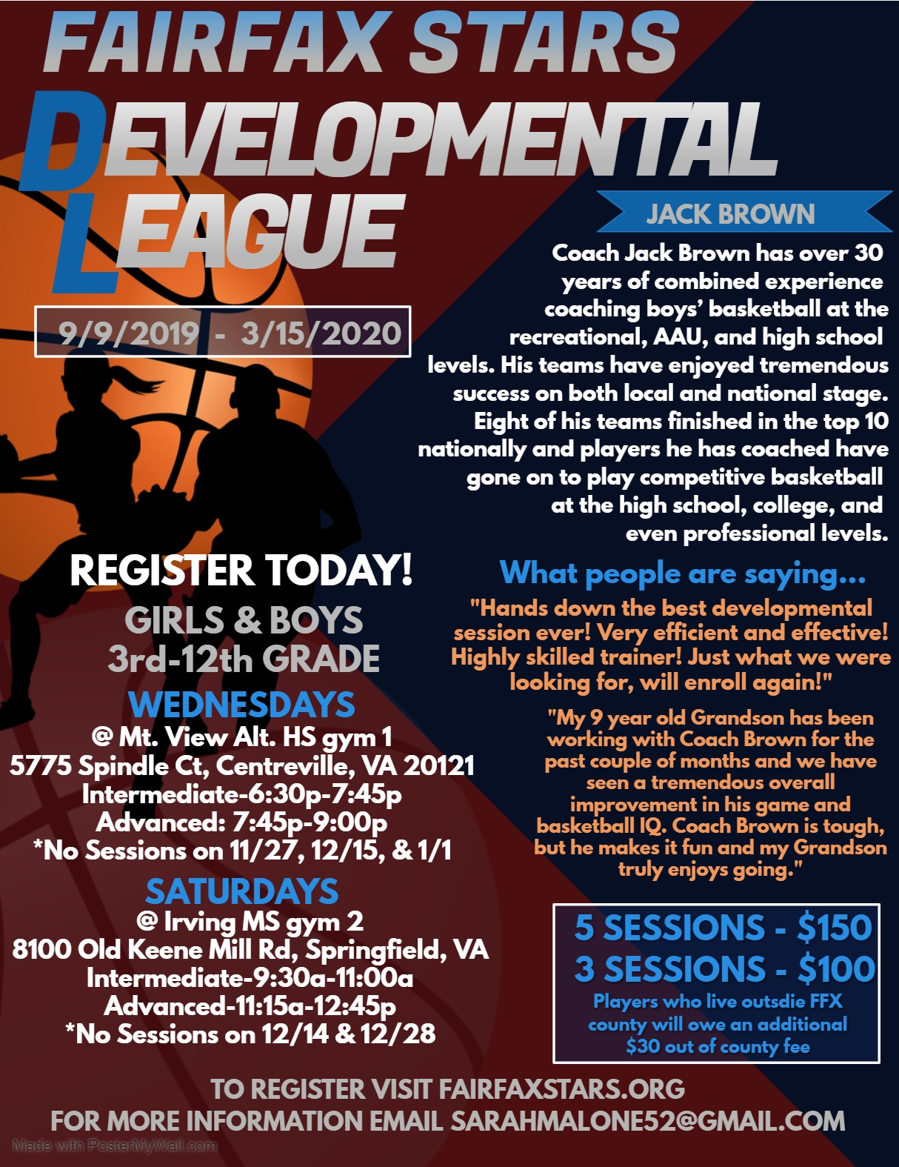

Registration Form for 2019-2020 Fairfax Stars Developmental League
Please type or print CLEARLY

Player Name: ____________________ Gender: _____ Age: ________ Date of Birth: ________

Grade: _____ School Player attends: ____________________ County of Residence: _________________

Address: _______________________________________________________________________

Phone Number: ___________________ Email Address: ____________________________

Please check which option best describes your skill level/basketball experience…

_______ County ______ House ________ AAU _______ other (__________) __________None

Check the Number of Sessions signing up for:

_____3 - $100 ____5- $150 (*players who live outside Fairfax County will need to pay additional $30 Out of county fee)

Please email Sarahmalone52@gmail.com or call 703-851-6231 to schedule your sessions from 9/9/2019-3/15/2020
*24 hours’ notice is required to reschedule a session. If you cannot attend a scheduled session and do not provide at least 24 hours’ notice a refund will not be issued for that session and it will not be rescheduled*

If any sessions are canceled due to the weather or other unforeseen circumstances, all attempts will be made to make up the session. In the event a session cannot be made up, no refunds will be given.
Forms can be filled out and emailed to sarahmalone52@gmail.com or mailed with payment to Fairfax Stars 2801 Glade Vale Way, Vienna, VA 22181
Checks made payable to Fairfax Stars
Registration and Payments can also be completed online at: www.fairfaxstars.org

_______________________________________________________________________________________
For administrative use ONLY

Amount Paid: __________ Payment Method: __________

Complete if paid by check-- Check Number: ________ Name on Check: _____________________

