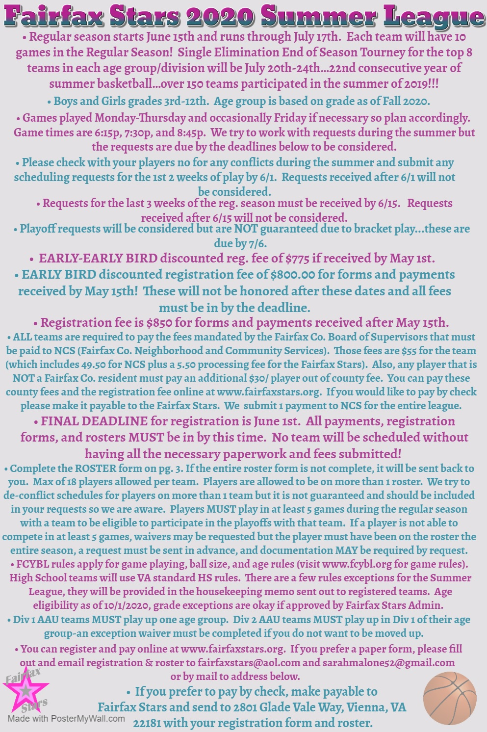

2020 Summer League Registration Form
(fill out COMPLETELY and LEGIBLY)

Team Name: ________________________________ Boys_____ Girls_____
Grade as of Fall 2020 (rising grade) _______
Level of Play: County____ CYO____ AAU____ House____ HS Rising Freshman____ HS JV____ HS Varsity____
Requested Division: Division 1 ____ Division 2_____
Div 1 AAU teams MUST play up one age group. Div 2 AAU teams MUST play up in Div 1 of their age group. Fairfax Stars will contact you to make sure your team is placed correctly if you marked Div 1 or Div 2 AAU (decided case by case).
Team City/St location for scheduling purposes when possible: ___________________________________
Coach Name _________________________________ 2nd Contact Name _____________________________
Cell Phone ____________________________________ Cell Phone __________________________________
Phone (H) _____________________________________ Phone (H) ___________________________________
Phone (W) ____________________________________ Phone (W) ___________________________________
Email (H) _____________________________________ Email (H) ____________________________________
Email (W) _____________________________________ Email (W) ___________________________________
Schedule Requests (please see detailed flyer for schedule request deadlines): ________________________________________________________________________________________________________________________________________________________________________________________________________________________________________________________________________________________________________________________________________________________________________________________________________________________

For Admin Use ONLY
Registration Payment Amount ________ Check/Order # _________ Name on Check/Order _______________
NCS Payment Amount ________ Check/Order # _________ Name on Check/Order _______________
Roster (circle one) Yes No Number of out of county on Roster ________

2020 Fairfax Stars Summer League Roster

Team Name:_______________________ Gender:_____ Grade:__________ Div. ___________

Please fill out and submit this page with all information filled in.
 | Player Name | Jersey # | DOB | Grade as of Fall 2020 | Address | County of Residence
1
2
3
4
5
6
7
8
9
10
11
12
13
14
15
16
17
18

